**PROJECT TITLE: BAKERY HOUSE MANAGEMENT SYSTEM**

**Course Title: Data Structure And Algorithm**

**Faculty: Kaneez Tahira Batool**



**SECTION-A (BETA)**

**Group Members:**

**Syed Moinuddin (2022F-BCS-028)**

**Eshan Ahmed Ansari (2022F-BCS-015)**

**Rizwan Hussain (2022F-BCS-021)**

**Muzammil (2022F-BCS-)**

**INTRODUCTION:**

The Bakery House Management System is designed to facilitate the management of a bakery's inventory, sales, and administration. It provides functionalities for adding bakery items, managing orders, processing payments, and accessing an admin panel for various administrative tasks.

***WELCOME PAGE:***



***MAIN MENU:***



**FEATURES:**

* **Item Management**: Add, view, and delete bakery items with details such as name, quantity, and price.
* **Order Processing:** Allow customers to place orders for bakery items, update stock levels upon purchase, and calculate total sales.
* **Payment Options:** Support cash and credit card payments, keeping track of transactions.
* **Admin Panel**: Accessible with a password for administrative tasks like viewing total cash, card transactions, adding new items, deleting items, system backup, and order previews.
* **User Interface**: Includes user-friendly menus and interfaces for ease of navigation.

***BAKERY ITEM LIST:***

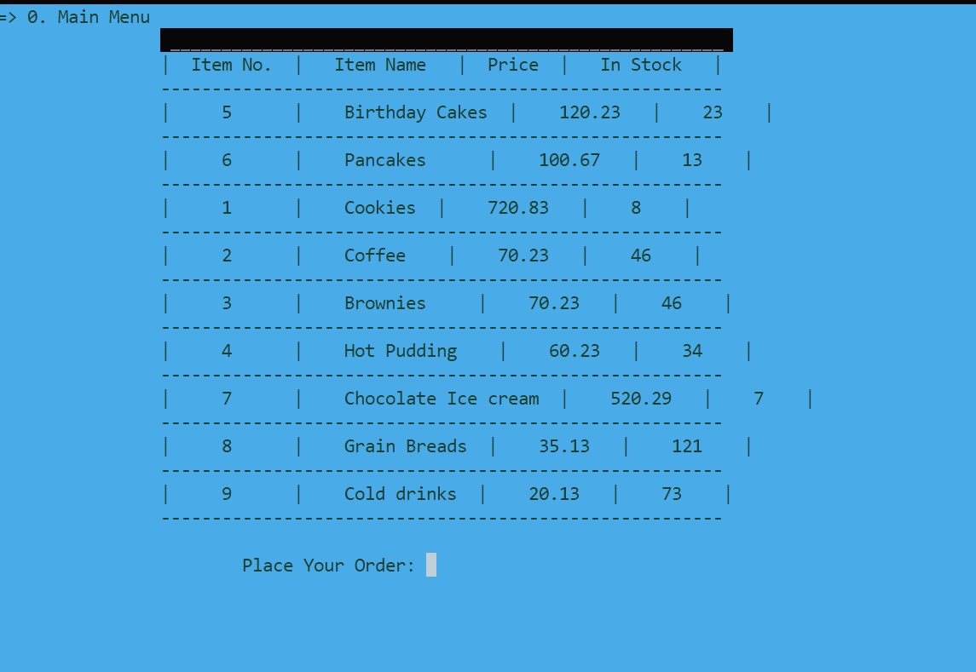

***AFTER CHOOSE ITEM:***

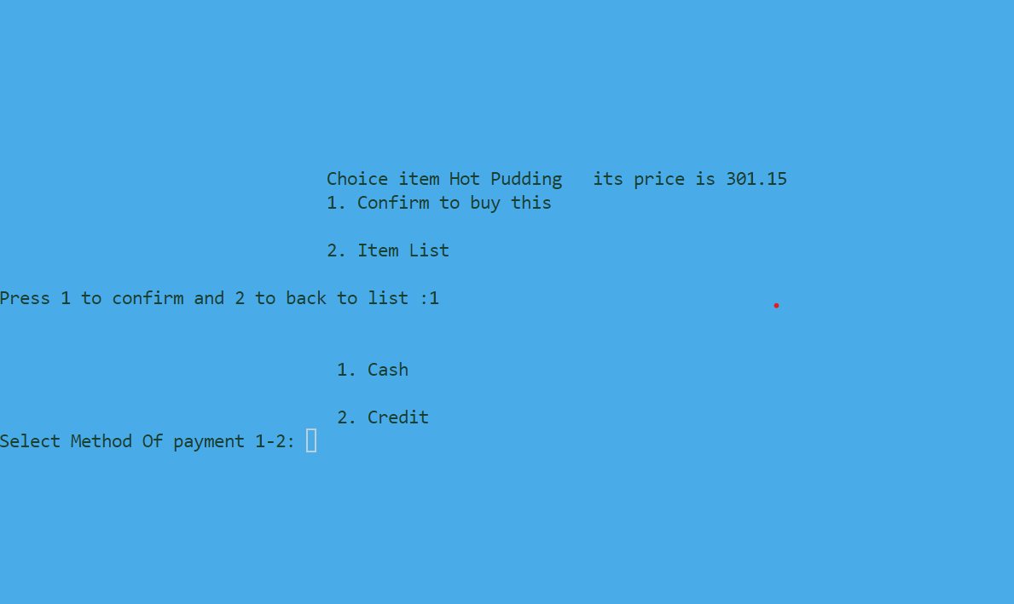

***IF WE CHOOSE CREDIT FOR PAYMENT METHOD:***

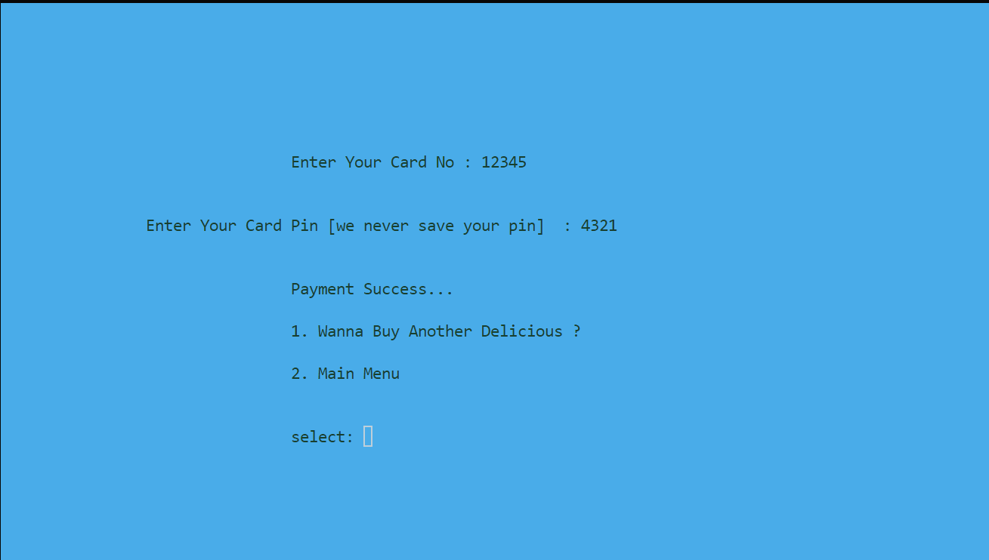

***ADMIN PANEL:***

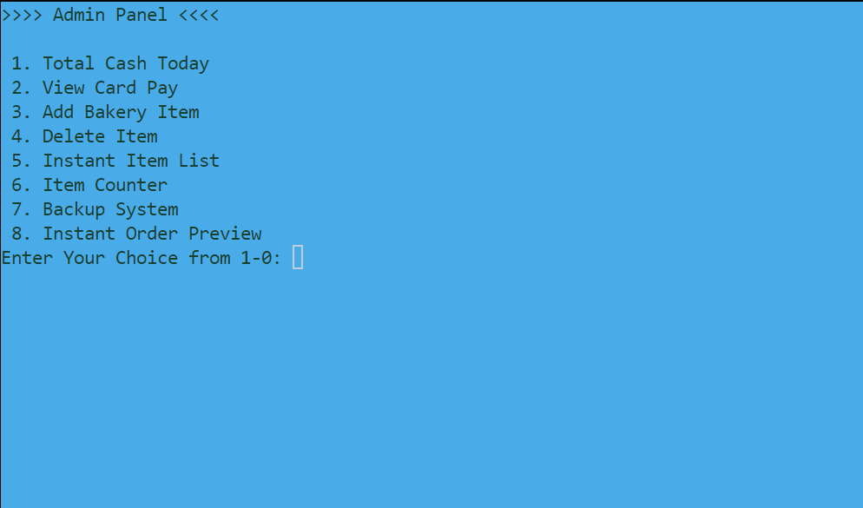

***Features of admin panel:***

*1.* ***Total Cash Today****: This option allows viewing the total cash earned on the current day by the bakery. It retrieves and displays the total earnings made throughout the day's transactions.*

*2.* ***View Card Pay****: In case customers make payments via card, this option provides a view of all card transactions. It displays a list that includes card numbers and the respective transaction amounts.*

*3.* ***Add Bakery Item****: This feature allows the admin to add new bakery items to the system. It prompts the admin to input details such as the item's name, quantity, unique serial number, and price. Upon submission, the new item gets added to the inventory.*

*4.* ***Delete Item****: Admins can remove bakery items from the system using this option. They need to provide the serial number of the item they wish to delete. Once confirmed, the system removes the item from the inventory.*

*5.* ***Instant Item List****: This feature displays an instant list of all available bakery items. It showcases item numbers, names, prices, and available quantities. This functionality offers a quick overview of the bakery's inventory.*

*6.* ***Item Counter****: This option counts and displays the total number of bakery items available in the system. It provides an accurate count of the items present in the inventory.*

*7.* ***Backup System****: The system allows admins to create backups of essential data. It generates a backup file, including crucial information such as the total cash earned for the day and card transaction details. These backups help in restoring data in case of any loss or system failure.*

*8.* ***Instant Order Preview****: This functionality displays an immediate preview of the current orders. It shows details such as the order number, item name, ordered quantity, and available stock. This allows admins to quickly view ongoing orders.*

***Each option in the Admin Panel serves a specific purpose, providing administrators with tools to manage inventory, track sales, and maintain the bakery system efficiently.***

**CODE OVERVIEW:**

The code is structured around a linked list implementation, where each node represents a bakery item with attributes like item name, quantity, price, and a unique serial number. Functions are defined to manage the linked list, perform operations like insertion, deletion, updating quantities, counting items, and displaying the food list.

***How to Use:***

*1. Upon running the program, the main menu displays options to view the food list, access the admin panel, or exit the system.*

*2. Users can select bakery items, choose quantities, and proceed with payment options (cash or credit card).*

*3. Admin access allows management tasks like viewing total cash, card transactions, adding/deleting items, system backup, and order previews.*

*4. The system provides a user-friendly interface to navigate through the options and perform desired actions.*

**CONCLUSION:**

The Bakery House Management System streamlines bakery operations by automating inventory management, order processing, and administrative tasks. With its user-friendly interface and comprehensive functionalities, it simplifies the management of a bakery's day-to-day operations.